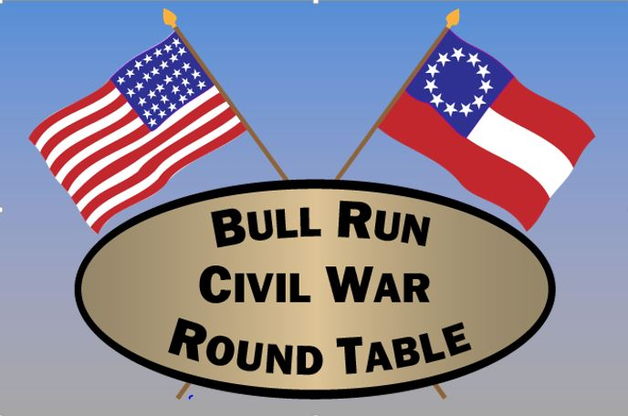
The Bull Run Civil War Round Table
P.O. Box 2147, Centreville, VA 20120
http://www.bullruncwrt.org
a 501(c)(3) Organization

MEMBERSHIP APPLICATION FORM

We are delighted that you are interested in joining the Bull Run Civil War Round Table and look forward to seeing you at our next meeting and at our upcoming events!

Annual Dues: Three-year Option:

Family: $25.00 Family: $65.00
Individual: $20.00 Single: $55.00
Students 25 & under): FREE

You may use PayPal by going to http://brcwrt.org/?page_id=962 and this form may be emailed to: brcwrttreasurer@gmail.com. Note that $1 is added to cover PayPal fee.
- OR -
You may pay by check payable to: BRCWRT (Bull Run Civil War Round Table) and hand this form and the check to the President or Treasurer at a General Membership meeting.
- OR –
Mail this form and the check to:
BRCWRT Treasurer
P.O. Box 2147
Centreville, VA 20120

NAME_________________________________________________________________

ADDRESS_____________________________________________________________

CITY____________________________________STATE_________ZIP____________

PHONE__________________EMAIL__________________________________________

How did you learn about the BRCWRT?______________________________________
(Friend, Facebook, Public Event etc.)

Do you have any Civil War activities you are particularly interested in in helping with (tours, selling used books, member recruitment, writing articles for the newsletter, annual picnic)? ______________________________________________________________________________

_______________________________________________________________________________

