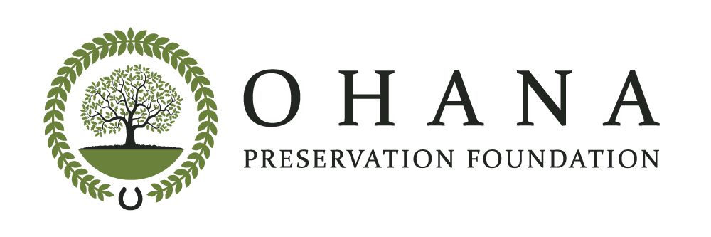
24203 Grand Ellison Court
Aldie, VA 20105
ohanapreservationfoundation@gmail.com

Dear Loudoun County Board of Supervisors,

The Ohana Preservation Foundation, a 501(c)(3) nonprofit organization, opposes ZOAM-2017-0001, Housing Affordability, as it relates to a density increase up to 30% in the TR-3 and TR-10 zoning districts in exchange for a small amount of affordable dwelling units. Ohana Preservation Foundation's mission through the Aldie Conservation Fund is to conserve and protect rural landscape, historic properties and farmland in Aldie, especially east of Route 15 where there are only a few existing conservation easements.

Currently, we are trying to preserve the land where the Battle of Mt. Zion occurred near the historic Mt. Zion Church and cemetery from development. This area is part of the gateway to rural Loudoun that begins at the Route 50 roundabouts and is an important historic and scenic resource. If the ZOAM is approved, we believe it will be more difficult to conserve this, and potentially other TR-3 zoned historic areas.

TR-3 and TR-10 zoning districts are the last remaining areas in the Transition Policy Area that have historic, natural and scenic resources. TR-10 is located near Goose Creek and TR-3 is located near Bull Run; both of which feed into reservoirs that are the source of our drinking water. These lower density areas are also located on the western edge of the Transition Policy Area abutting the Rural Policy Area. Other considerations are the fact that infrastructure is limited in these areas and during the 2019 Comprehensive Plan, residents overwhelmingly supported more open space, parks, and trails.

We understand the need for affordable housing; however, this is neither the right location nor the right strategy. We think that these by-right density increases should not be approved until the Unmet Housing Need Strategic Plan is completed with a cost/benefit analysis of the various strategies. Relying on market rate growth to provide adequate affordable housing has failed to meet the need. Loudoun County needs a new affordable housing policy that is comprehensive and cost-effective.

Thank you,

Melissa Pankas
Melissa Pankas
President
Ohana Preservation Foundation

