Virginia Cavalry Battles
Prelude to Gettysburg
(Upperville, Middleburg and Aldie)
. BRCWRT car caravan tour
Saturday May 6

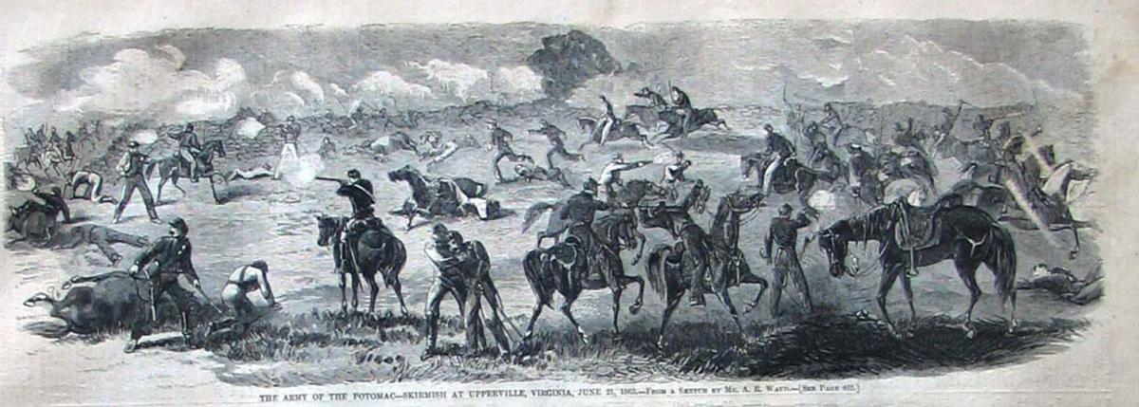

Subject matter: As the Army of Northern Virginia moved north thru the Shenandoah Valley (culminating in the Battle of Gettysburg) General Stuart was tasked with screening the march and the Union cavalry tried to pierce the screen to determine Lee’s plans.
Tour Guide: Kevin Pawlak , Historian and Expert on these battles and the war in Virginia piedmont.
Lunch: Hunters Head in Middleburg. Individual tabs.
Transportation: We will carpool from Mt. Zion Church Historic Park. Some walking will be involved.
Time/Location: 8:30 Meet at Mount Zion Church Historic Park (40309 John Mosby Hwy, Aldie, VA 20105) to arrange car pools and tour the church at 9 depart from church at 9:30. Tour ends approximately at 3:15 at Mt. Zion Church.
Uniform of the Day: dress for local weather conditions, wear comfortable walking shoes and bring a walking stick, as necessary
BRCWRT Contact: John Scully scullycivilwar@gmail.com 703 869 4036
The tour is FREE! If interested in attending, please sign up via BRCWRT’ website or the April meeting.

